UNIT-II

NETWORK THEOREMS
  - Find the current passing through 3Ω Resistor for the circuit shown below in Fig(a) by using Superposition Theorem?
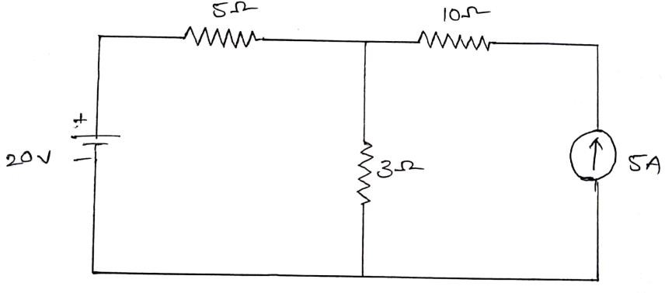
Fig. (a)
  - Determine the Norton’s equivalent circuit for the circuit shown in Fig.(b)

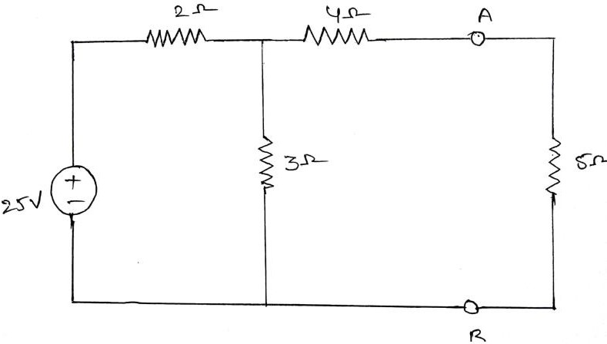
Fig.(b)

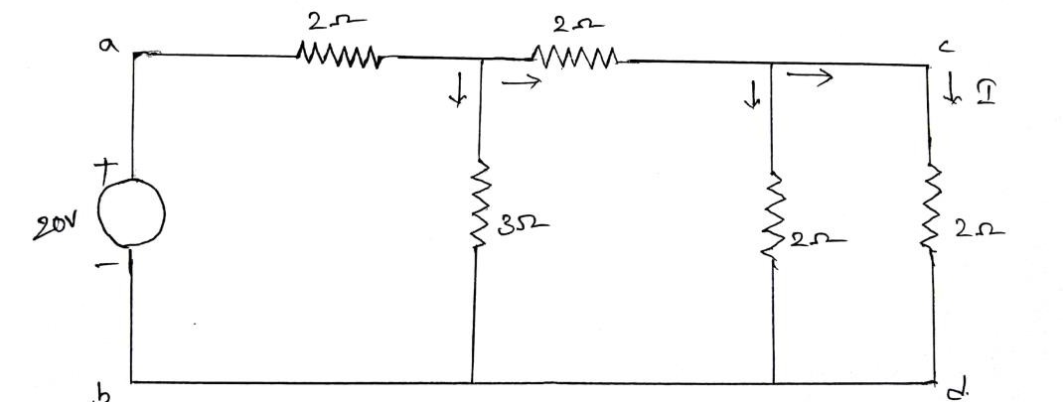
  - Verify Reciprocity Theorem for the network shown in figure (d)
Fig. (d)
  - Determine the Norton’s equivalent circuit for the circuit shown in Fig.(e)

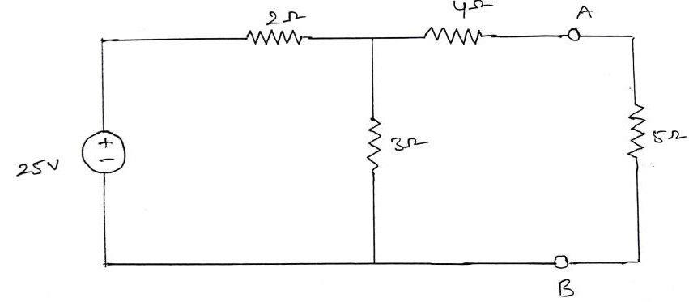
Fig. (e)

  - Determine the voltage across (2+j5) Ω impedance as shown in figure. (f) by using Super position Theorem?
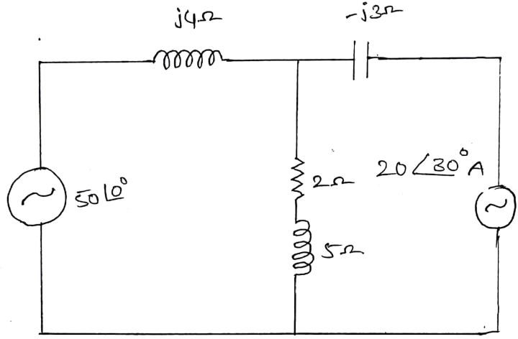
Fig. (f)

  - Determine the Thevenin’s equivalent circuit for the circuit shown in figure. (g).
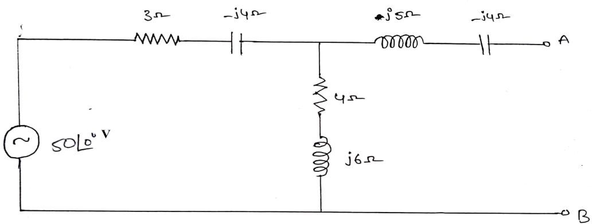
Fig. (g)

  - Determine the Norton’s equivalent circuit for the circuit shown in figure. (h)
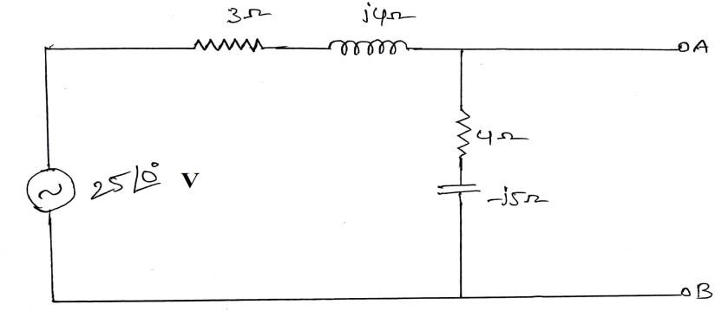
Fig. (h)
  - For the circuit shown in figure. (i), find the value of load impedance for which the source delivers maximum power. Also calculate the value of maximum power.
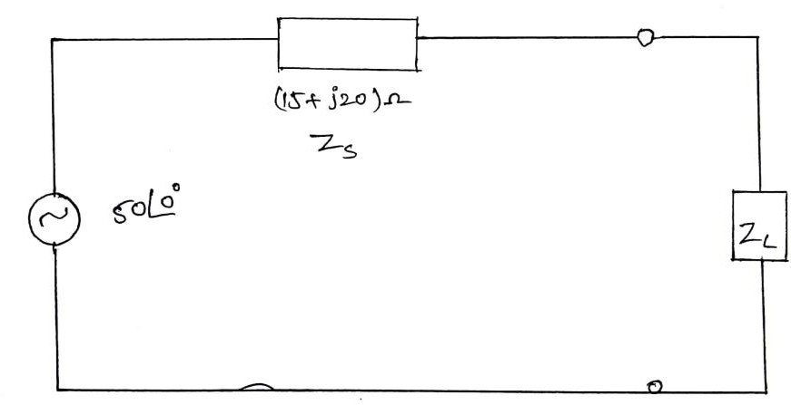
Fig. (i)
  - Derive the condition for the maximum power to be transferred from the source to the load.
  - Statement of
- Superposition theorem
- Reciprocity theorem
- Thevenin’s theorem
- Norton’s theorem
- Maximum Power Transfer Theorem

